**Session5**

**Center-state relationship: Legislative, Administrative and Financial**

Centre State Legislative Relations

Articles 245 to 255 in Part XI dictates the legislative relations between the Centre and the State.The Parliament can make laws for the whole or any part of the territory of India. Territory of India includes the states, UTs and any other area for the time being included in the territory of India. Whereas, the state legislature can make laws for whole or any part of state.

Centre State Administrative Relations

The administrative jurisdiction of the Union and the State Governments extends to the subjects in the Union list and State list respectively. The Constitution thus defines the clauses that deal with the administrative relations between Centre and States.

Centre State Financial Relations

The Parliament has exclusive power to levy taxes on subjects enumerated in the Union List, the state legislature has exclusive power to levy taxes on subjects enumerated in the State List, both can levy taxes on the subjects enumerated in Concurrent List whereas ultimate power of taxation lies with Parliament only.

**Individual Task 1: Read and collect more factual details on the Legislative,**

**Administrative and Financial relations between Center and State. Answers should be submitted as an assignment of minimum FOUR pages with proper citations and later attached to the booklet. (10 Marks)**

**(OR)**

**Group Task 1: Make and submit a poster/collage explaining and illustrating the Legislative, Administrative and Financial relations between the Center and the State.**

**(10 Marks)**

|  |
| --- |
| **Debarghya Barik**  **RA2011026010022**  **COI Session 5 27.11.2020** |

# ----Central State Relation----

Legislative, Administrative and Financial



|  |
| --- |
| The framers of the Indian constitution perceived the need for a strong Central Government, which would keep the disintegrating force in check and safeguard the integrity of the country. This aspect has made the Indian federation a unique one among the federal structures of the worlds. It is characterised by high degree of centralization. The Indian constitution can be both unitary as well as federal according to the requirements of time and circumstances. The Constitution is federal in form but unitary in spirit. |

|  |
| --- |
| The Constitution of India provides a dual polity with a clear division of powers between the Union and the States, each being supreme within the sphere allotted to it. The Indian federation is not the result of an agreement between independent units, and the units of Indian federation cannot leave the federation.  Thus the constitution contains elaborate provisions to regulate the various dimensions of the relations between the centre and the states. |

|  |
| --- |
| **Debarghya Barik**  **RA2011026010022**  **COI Session 5 27.11.2020** |

|  |
| --- |
| **The relations between centre and state are divides as:**   * Legislative relations * Administrative relations * Financial relations |



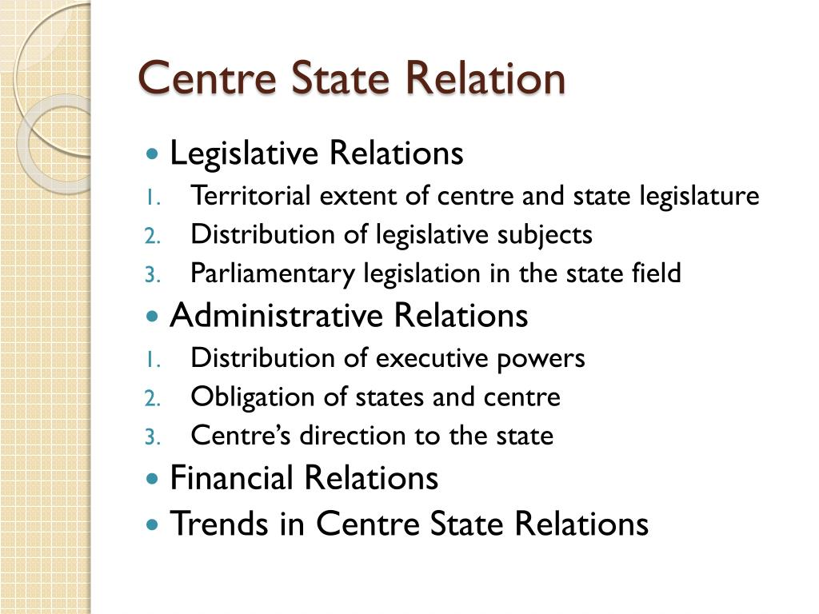

|  |
| --- |
| **Debarghya Barik**  **RA2011026010022**  **COI Session 5 27.11.2020** |

**Legislative relations:**

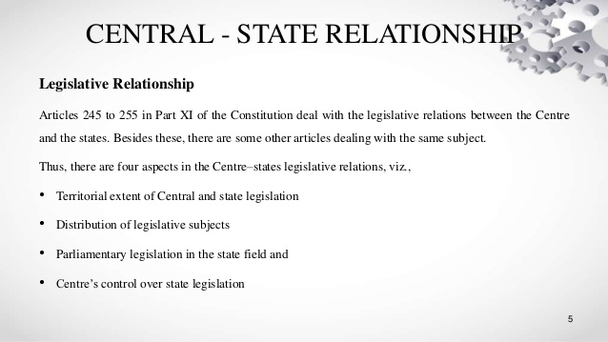

|  |  |
| --- | --- |
| The Constitution divides legislative authority between the Union and the States in three lists –   |  | | --- | | * The Union List, * The State List and * The Concurrent List. |   *The Union List* consists of 99 items. It demonstrates the vast extent as well as the great importance of the powers vested in the Union government. The Union Parliament has exclusive authority to frame laws on subjects enumerated in the list. These include foreign affairs, defence, armed forces, communications, posts and telegraphs, foreign trade, inter -state trade, commerce, etc. A number of items included in the list have an important bearing on Union State relations and some of them can enable the Union to expand its area of operation and thereby extend its control over the sphere, which falls under State jurisdiction. For example, item number 52, which refers to industry, places a powerful lever in the hands of the Union to take any industry under its own control.  Both the Parliament and the State Legislatures can make laws on subjects given in the *Concurrent List*, but the centre has a prior and superior claim to legislate on concurrent subjects. The list comprises of 52 items including criminal and civil procedure, marriage and divorce, economic and special planning, trade union, labour welfare, electricity, newspapers, books and printing presses, population control and family planning etc.  *The State List* consisting of 61 items contains subjects on which ordinarily the States along can make laws. These include public order, police, administration of justice, prisons, local government, agriculture etc. However, what makes State autonomy less real than it appear s at first is the fact that under certain conditions the Constitution authorizes the Union Government to extend its over matters formally included in the State List |

-----------------------------------------------

**Administrative relations:**

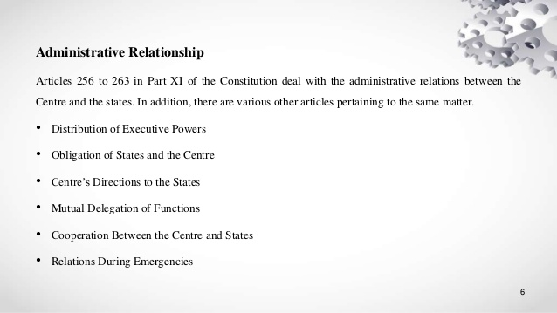

|  |
| --- |
| **Debarghya Barik**  **RA2011026010022**  **COI Session 5 27.11.2020** |

|  |
| --- |
| The *Administrative relations* between the Union and the States offer yet another proof of the highly integrated nature of the Indian federation. Under the constitution the Union government can exercise the executive power in respect of all matters within its legislative jurisdiction. Some of these matters, such as customs, and central excise, income tax, Railways, post and Telegraphs are administered directly by services maintained by the Union Government. In most of the cases, the administration of Union matters is delegated to State authorities.  The Union-State administrative relations in India are organized as to enable the Union Government exercise considerable direction and control over the administrative machinery of the States. The constitution on places upon the States the obligation to exercise their executive authority in such a way as to ensure compliance with the Union laws. |

--------------------------------------------

**Financial relations:**

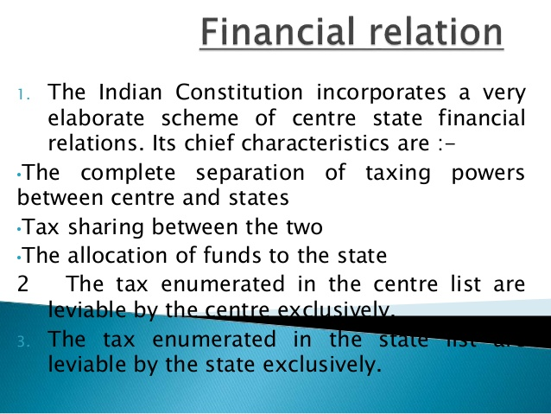

|  |
| --- |
| **Debarghya Barik**  **RA2011026010022**  **COI Session 5 27.11.2020** |

|  |
| --- |
| The Constitution provides for a *financially strong centre* so much so the States are almost totally *dependent* on the Union. The outstanding feature of Indian finances is that most of the resources accrue to the Union and out of these some are transferred to States.  Scheme of distribution of revenue:  Art. 268 provides the scheme of the distribution of revenue between the Union and the States. The States possess exclusive jurisdiction over taxes enumerated in the State List. The Union is entitled to the proceeds of the taxes in the Union List. The Concurrent List included no taxes. However, while the proceeds of taxes within the State List are entirely retained by the States, proceeds of some of the taxes in the Union List be allotted, wholly or partially, to the States. The Constitution mentions four categories of Union taxes, which are wholly or partially assigned to the States. |

--------------------------------------------

**An Assessment of Centre-State Relations:**

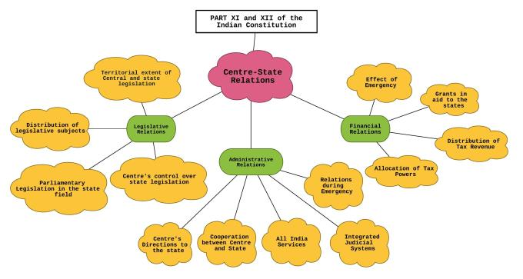

|  |
| --- |
| **Debarghya Barik**  **RA2011026010022**  **COI Session 5 27.11.2020** |

|  |
| --- |
| A critical examination of the legislative, administrative and financial relations makes it very clear that under the Indian federal system the Centre has been assigned a very predominant role. The States are heavily dependent upon the Union Government. The Constitution has some conspicuous unitary features. These are:  (a) A single Constitution both for the Centre and the States, with the exception of Jammu and Kashmir,  (b) A major part of the Constitution can be amended by the parliament alone and the exclusive right of the Parliament to propose amendments,  (c) Provision for a single all-India citizenship with the exception of Jammu and Kashmir,  (d) The power of the Parliament to change the name, territory or boundary of States without their consent;  (e) The appointment of the governor of a State by the President and his functioning as the agent of the Centre.  For these reasons some critics have called India a centralized federation. It appears that the Constitution makers envisaged a co-operative federalism in which the Union ends the States should collaborate with each other for the common good. |

|  |
| --- |
| **Debarghya Barik**  **RA2011026010022**  **COI Session 5 27.11.2020** |

***Presentation in a Gist:***



